

TRAVEL MANAGEMENT SYSTEM

***Submitted by***

**KAVIPRIYA M A (231001085) KAVYA ROSHINI M U (231001088)**

MINI PROJECT NOVEMBER - 2024

***DEPARTMENT OF INFORMATION TECHNOLOGY***

# RAJALAKSHMI ENGINEERING COLLEGE, THANDALAM

**BONAFIDE CERTIFICATE**

Certified that this project report titled “**TRAVEL MANAGEMENT SYSTEM**” is the Bonafide work of **KAVIPRIYA M A (231001085), KAVYA ROSHINI M U (231001088)** who carried out the work under mysupervision. Certified further that to the best of my knowledge the work reported hereindoes not form part of any other thesis or dissertation on the basis of which a degree oraward was conferred on an earlier occasion on this or any other candidate.

**SIGNATURE SIGNATURE**

**Valarmathie.P Sangeetha.T**

**Head of The Department Professor,**

Department of Information Technology Department of Information Technology Rajalakshmi Engineering College Rajalakshmi Engineering College

Submitted to Project Viva-Voce Examination held on

**Internal Examiner External Examiner**

**ABSTRACT**

The Travel Management System is a database-driven application designed to assist travel agencies, tour operators, and individual users in managing travel-related data. This system serves as a comprehensive platform for recording, analyzing, and retrieving information about trips, travelers, bookings, and service providers.

The project tests the ability to design and implement a scalable and relational database system, incorporating real-time data analysis and visualization to support travel planning and management. While there is guidance in the development phase, the project showcases independent problem-solving and technical skills.

Our system aims to streamline travel data management and provide actionable insights. Trips are recorded with details such as destination, duration, and travel dates. Travelers' profiles are maintained, including preferences and past trips. Bookings and associated service provider activities are tracked, ensuring smooth operations and transparency.

The system enables travel agencies to access detailed trip data, analyze trends, and make informed decisions. By facilitating seamless data storage and retrieval, the Travel Management System enhances the efficiency of trip planning and execution while supporting advanced analytical capabilities like identifying popular destinations, seasonal trends, and customer preferences.

**TABLE OF CONTENTS**

|  |  |  |
| --- | --- | --- |
| **CHAPTER NO** | **TITLE** | **PAGE NO** |
|  | **ABSTRACT** | 3 |
|  | **LIST OF TABLES** | 5 |
|  | **LIST OF FIGURES** | 5 |
|  | **LIST OF ABBREVIATIONS** | 5 |
| **1** | **INTRODUCTION** | 6 |
| **1.1 Motivation** | 6 |
| **1.2 Existing System** | 6 |
| **1.3 Project Objectives** | 7 |
| **1.4 Proposed System** | 7 |
| **2** | **SYSTEM DESIGN** | 8 |
| **3.1 Introduction** | 8 |
| **3.2 System Architecture** | 8 |
| **3.3 System Requirements** | 9 |
| **3** | **PROJECT DESCRIPTION** | 10 |
| **3.1 Methodologies** | 10 |
| **3.2 Module Description** | 10 |
| **4** | **Results** | 11 |
| 43 | **Output Images** | 12 |
|  | **CONCLUSION** | 13 |

**LIST OF TABLES**

|  |  |
| --- | --- |
| TABLE | **PAGE NUMBER** |
| Table 3.1 | 10 |

**LIST OF FIGURES**

|  |  |
| --- | --- |
| **TABLE** | **PAGE NUMBER** |
| Fig 4.1 | 11 |
| Fig 4.2 | 11 |
| Fig 4.3 | 12 |
| Fig 4.4 | 12 |
| Fig 4.5 | 13 |

**CHAPTER - 1 INTRODUCTION**

### MOTIVATION

Travel remains a significant part of modern society, affecting economic growth, cultural exchange, and individual well-being. Traditional methods of managing travel-related data often involve scattered systems, manual record-keeping, and a lack of integration, leading to inefficiencies, errors, and limited analytical capabilities. The growing demand for seamless travel experiences, real-time information, and personalized services calls for a more advanced and scalable solution to support the management of trips, bookings, and travel services.

This project is motivated by the need to address these challenges and create a unified, efficient, and insightful system. By leveraging modern database technologies and analytical tools, the Travel Management System aims to provide stakeholders with timely and accurate data, enabling better decision-making, enhanced customer experiences, and optimized travel planning. Ultimately, the system strives to contribute to smoother travel experiences, improved operational efficiency, and more informed travel choices.

* 1. **EXISTING SYSTEM**

#### Fragmented Data Management: Travel data is often stored in separate systems, making it hard to bring everything together and access the information quickly.

* + 1. **Manual Processes**: Booking and travel planning are often done manually, which can lead to errors, delays, and inefficiencies. These processes are time-consuming and prone to human mistakes.
    2. **Limited Analytical Tools**: Current systems don’t offer much help in analyzing travel trends or customer preferences, making it harder to optimize services.
    3. **Accountability Challenges**: It’s difficult to keep track of customer interactions and service activities, which reduces transparency and accountability.
    4. **Accessibility Issues**: Getting easy access to travel data, especially for decision- makers or researchers, can be hard without clear and visual insights.

### 1.3 PROJECT OBJECTIVES

* **Travel Records Management**: Ability to store, retrieve, and update details of booked trips, itineraries, and customer information.
* **Traveler Profiling:** Detailed profiles of travelers, including preferences, past trips, and special requirements
* **Booking Management**: Record and track the status of trip bookings, confirmations, and cancellations.
* **Destination Tracking**: Geographical representation of popular travel destinations, seasonal trends, and travel patterns.
* **Analytics Dashboard**: Displays trends and summaries of travel data, customer behavior, and booking patterns to help agencies optimize services.

### PROPOSED SYSTEM

The Travel Management System offers a comprehensive solution for managing travel bookings, itineraries, and customer interactions. The system integrates functionalities such as booking management, payment processing, itinerary planning, and real-time updates. It is designed to assist travel agencies in providing seamless services to their customers, improving operational efficiency, and enhancing customer satisfaction. The system's scalable architecture allows for future features such as AI-based recommendations and real-time travel alerts.

**BENEFITS OF THE PROPOSED SYSTEM**

* **Informed Decision-Making:** Provides travel agencies with data-driven insights to improve travel packages, customer engagement, and service offerings.
* **Improved Efficiency:** Streamlines the booking and reservation process, reducing manual effort and minimizing errors.
* **Enhanced Customer Experience:** Offers personalized travel options and efficient management of bookings, leading to higher customer satisfaction.
* **Collaboration and Transparency:** Facilitates coordination between travel providers, ensuring smooth communication and transparency in service delivery.
* **Scalability and Flexibility:** Easily adaptable to include new features like real-time flight updates or advanced payment processing, supporting business growth.
* **Cost Reduction:** Reduces overhead and operational costs by automating processes and improving resource allocation.

**CHAPTER – 2**

### SYSTEM DESIGN

* 1. **INTRODUCTION**

The Travel Management System is designed to simplify and enhance the travel planning and booking process by integrating modern technologies into a user-friendly and scalable platform. The system is structured to support efficient management of customer bookings, itinerary planning, and payment processing while maintaining flexibility for future enhancements. It aims to streamline operations for travel agencies, improve customer satisfaction, and ensure smooth travel experiences from booking to trip completion.

### SYSTEM ARCHITECTURE

The system architecture is based on a three-tier design includePresentation Layer, Application Layer, and Data Layer.

#### Presentation Layer (Front-End)

* Technology: JavaFX
* Purpose: Provides a graphical user interface (GUI) for customers and administrators to interact with the system. It accepts user input for tasks like booking travel, managing itineraries, and processing payments.
* Components:
  + Dashboards: Display travel options, upcoming trips, and user preferences.
  + Forms: Input fields for booking flights, hotels, and other travel services.
  + Reports: Generates reports on customer bookings, payments, and travel history.

#### Application Layer (Logic/Controller Layer:

* Technology: Java (Core and JDBC)
* Purpose: Handles the business logic and processes user requests. It manages data validation, manipulation, and integrates the front-end with the database.
* Key Modules:
  + Booking Controller: Manages travel bookings, from initial queries to final confirmation.
  + Payment Processing: Handles payment transactions and updates booking statuses.
  + Request Handling: Routes user requests (e.g., booking a trip, viewing itineraries) to the appropriate system functions.

#### Data Layer (Back-End)

* Technology: MySQL
* Database Design:
* Tables:
  + Customers: Stores customer details (name, contact, preferences).
  + Bookings: Tracks travel bookings (flight, hotel, transport details).
  + Payments: Stores payment information (transaction IDs, amounts).
  + Itineraries: Organizes travel schedules, including activities and services.
* Relationships:
  + Customers are linked to Bookings (one-to-many).
  + Bookings are associated with Itineraries (one-to-one).
  + Payments are linked to Bookings (one-to-one).

### SYSTEM REQUIREMENTS

**HARDWARE SPECIFICATIONS:**

PROCESSOR : Intel i5 MEMORY SIZE : 4GB(Minimum)

HARD DISK : 500 GB of free space

**SOFTWARE SPECIFICATIONS:**

PROGRAMMING LANGUAGE : Java, MySQL FRONT-END : JavaFx

BACK-END : MySQL

OPERATING SYSTEM : Windows 11

**CHAPTER - 3 PROJECT DESCRIPTION**

* 1. **METHODOLOGIES**

|  |
| --- |
| **PRESENTATION (FRONTEND) LAYER** |
| JavaFX (GUI : Forms,Charts) |

|  |
| --- |
| **APPLICATION (BACKEND) LAYER** |
| JAVA and JDBC Connectivity |

***Table 3.1***

|  |
| --- |
| **DATA(DBMS)LAYER** |
| MYSQL(Tables,Views) |

# MODULE DESCRIPTION

* + - DASHBOARD PAGE
    - CUSTOMER RECORD PAGE
    - BOOKED HOTEL PAGE
    - PACKAGE PAGE
    - ABOUT PAGE

**CHAPTER – 4 RESULTS**

**Output Images**

* 1. **Dashboard**



***Fig 4.1***

* 1. **Customer records page**

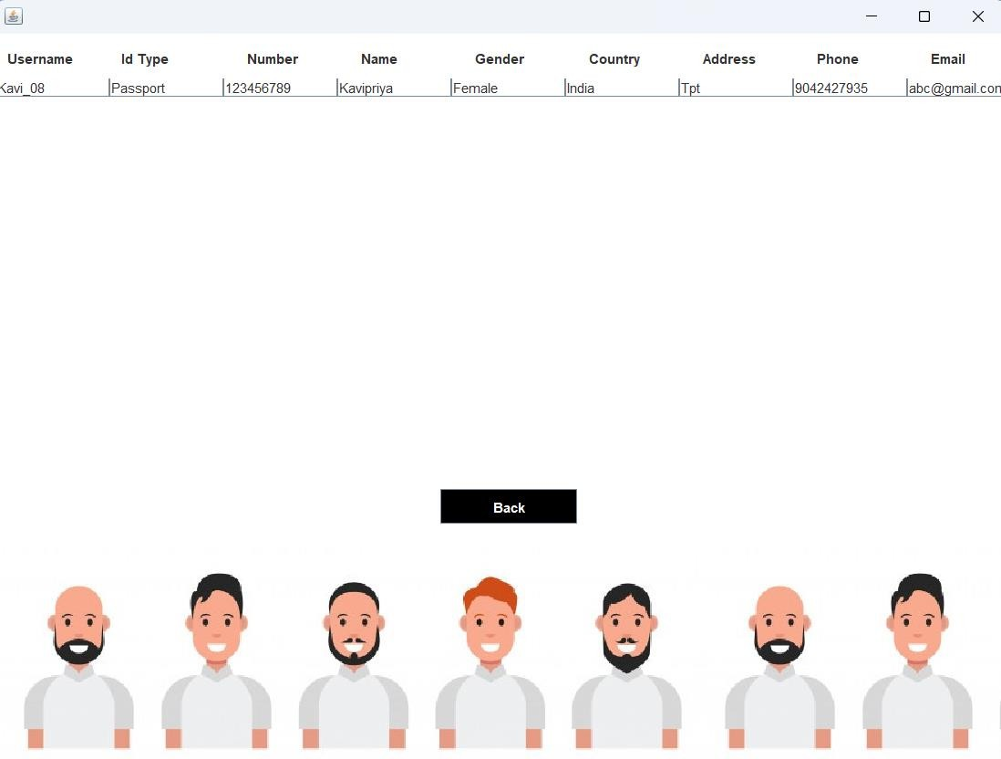

## Fig 4.2

* 1. **Booked Hotel Page**

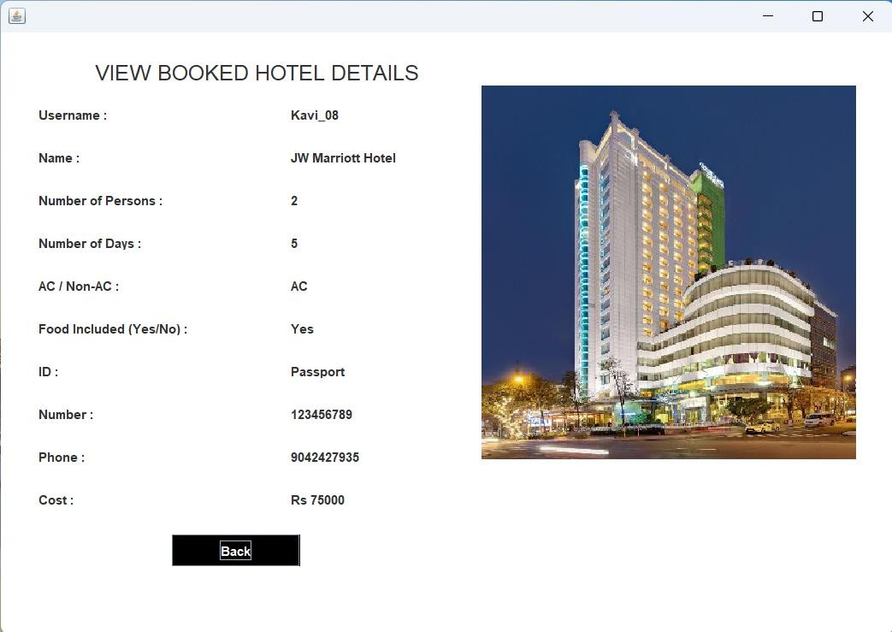

## Fig 4.3

* 1. **Package Page**

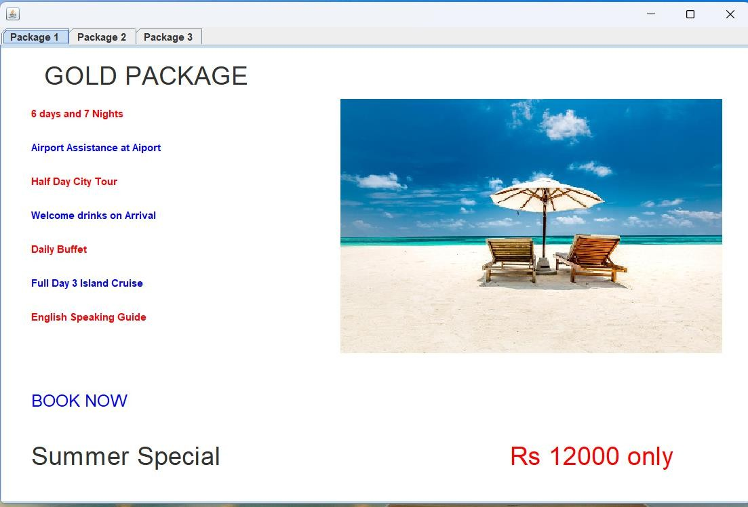

***Fig 4.4***

* 1. **About Page**

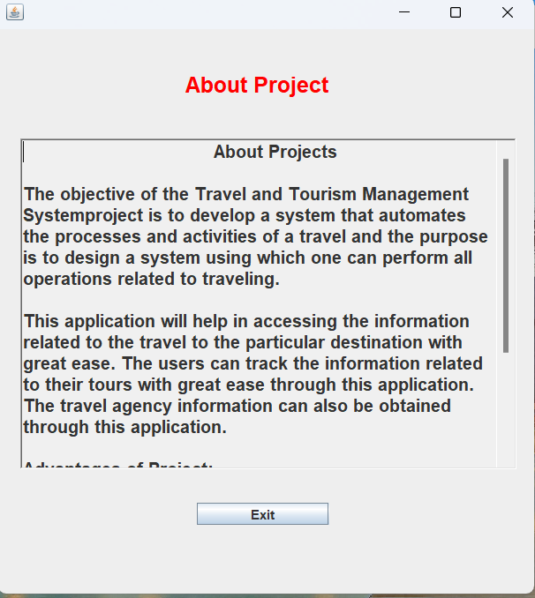

***Fig 4.5***

### CONCLUSION

The Travel Management System simplifies the entire process of booking, managing, and organizing travel. With this system, travel agencies, customers, and administrators can efficiently manage bookings, plan itineraries, process payments, and access detailed reports. By centralizing all travel-related data and making it easily accessible through an intuitive dashboard, the system saves time and resources. Additionally, it enhances decision-making by providing insights into customer preferences, booking trends, and payment histories. Ultimately, the system improves operational efficiency, customer satisfaction, and the overall travel experience.